**Assignment -4**

Digital Marketing

|  |  |
| --- | --- |
| Student Name | Angeline Daphne K |
| Student Roll Number | 20URCS005 |
| NM ID | C359CF15BB6916A915C4DABC209622CE |
| College Name | AAA College of Engineering and Technology |

**QUESTION:**

**Create email newsletter design using MailChimp or Canva tool.**

**EMAIL NEWSLETTER USING CANVA:**

**Newsletter link:** https://donutsdazzle.blogspot.com/2023/09/donuts-dazzle.html

**Newsletter Title: Donuts Dazzle**

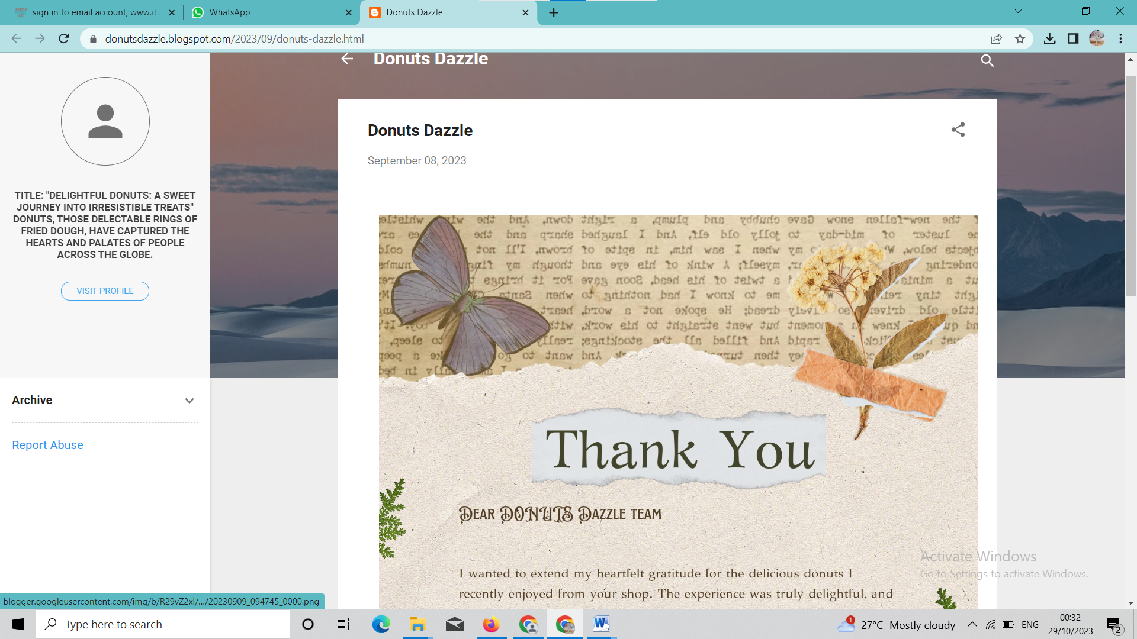

**Email Newsletter:**

